FoodDelivery System

***The main purpose of FoodDelivery system is to provide restaurants, cafes or other food establishments with ability to sell their foods online by quick and easy online menu management.***

**Guest** has the ability to browse menu, select items, view their detailed information, add them to basket, edit items quantity, or completely remove them from basket. After those steps based on items in the basket guest can submit order for processing. User will be able to see order status information, and other delivery information. Any time guest can register in the system.

**User,** has all of the functionality presented to the guests plus and some additional features such as ability to save payment, delivery information, which adds extra convenience when placing orders. Receive certain discounts base on order history.

**Manager** processes orders placed by customers, sets and updates delivery status, estimates delivery time. Manager is also responsible for menu management, has ability to add, update, remove, menu items, puts or removes discounts on some of them. Also manager can create or delete menu filters.

**Admin,** has all manager rights + responsible for site content management, user and user role management.

# Subsystems

## Menu Management

|  |  |  |  |
| --- | --- | --- | --- |
| **№** | **Use Case** | **Role** | **Description** |
| MM1 | Add menu item | Manager, Admin | Menu can be populated with new items. |
| MM2 | Edit menu item | Manager, Admin | Existing items in menu can be edited. |
| MM3 | Delete menu item | Manager, Admin | Menu item can be completely deleted from menu. |
| MM5 | Add discount | Manager, Admin | Any time discount can be created and assigned to certain items in menu. |
| MM6 | Delete discount | Manger, Admin | Any time discount can be removed from certain menu items if they have one. |
| MM7 | Create filter category | Manger, Admin | To search faster in menu, new filter category can be created. |
| MM8 | Edit filter category | Manger, Admin | Filter categories can be updated. |
| MM9 | Delete filter category | Manager, Admin | Filter categories can be completely removed. |
| MM10 | View menu items | User, Guest, Manager, Admin | Menu items can be viewed by all roles. |
| MM11 | Apply filters to menu | User, Guest, Manger, Admin | For better search anyone can filter menu. |

## Order Management

|  |  |  |  |
| --- | --- | --- | --- |
| **№** | **Use Case** | **Role** | **Description** |
| OM1 | Add item to basket | User, Guest | Menu items can be added to basket then orders are formed based on them. |
| OM2 | Delete item from basket | User, Guest | Items can be removed from basket. |
| OM3 | Edit item quantity in basket | User, Guest | Quantity of items in basket can be updated. |
| OM4 | Submit order | User, Guest | Based on basket content order will be created and submitted for processing. |
| OM5 | Cancel order | User, Guest | Order can be canceled before it has been approved by restaurant. |
| OM6 | View order status | User, Guest | Every order has its processing status, gives user ability to track delivery info. |
| OM7 | Accept order | Manager, Admin | Submitted orders can be approved if restaurant is able to deliver. |
| OM8 | Decline order | Manger, Admin | For some reasons restaurant may be unable to handle order, so it can be declined. |
| OM9 | Update order status | Manager, Admin | Every order has its processing status, it has to be updated so user will have correct delivery information. |

## User Management

|  |  |  |  |
| --- | --- | --- | --- |
| **№** | **Use Case** | **Role** | **Description** |
| UM1 | Add personal information | User, Manager | User can add personal information(address, phone number) |
| UM2 | Edit personal information | User,  Manager | User can edit personal information(address, phone number) |
| UM3 | Delete personal information | User,  Manager | User can delete personal information(address, phone number) |
| UM4 | Save payment, delivery information | User | For easier order creation, payment, delivery info can be saved as template |
| UM5 | Edit payment, delivery information | User | Payment, delivery information can be edited |
| UM6 | Delete payment, delivery information | User | Payment delivery information can be deleted |
| UM7 | Create user account | Guest, Admin | User account can be created by registration, or admin privileges |
| UM8 | Delete user account | Admin | Some accounts can be deleted |
| UM9 | Assign role to user account | Admin | Certain roles can be assigned to certain accounts |

# Tests

|  |  |  |
| --- | --- | --- |
| **№** | **TestClass** | **Test method** |
| TST1 | BasketServiceTest | AddSeveralTimeTheSameMenuItemInUserBasketSuccssesfully |
| TST2 | AddNewMenuItemInUserBasketSuccssesfully |
| TST3 | AddNewMenuItemInUserBasketInvalidUserName |
| TST4 | AddNewMenuItemInUserBasketInvalidMenuItemId |
| TST5 | DeleteMenuItemFromUserBasketSuccssesfully |
| TST6 | DeleteMenuItemFromUserBasketWhatDoesNotExistInBasket |
| TST7 | DeleteMenuItemFromUserBasketInvalidUserName |
| TST8 | DeleteMenuItemFromUserBasketInvalidMenuItemId |
| TST9 | SubmitCartSuccessfully |
| TST10 | SubmitCartForNotExistingUser |
| TST11 | ClearCartSuccessfully |
| TST12 | ClearCartForNotExistingUser |
| TST13 | GetAllItemsFromUserCartSuccessfully |
| TST14 | GetAllItemsFromNotExistingUserCart |
| TST15 | GetItemsFromUserCartByPriceDescendingSuccessfully |
| TST16 | GetItemsFromUserCartByItemNameSuccessfully |
| TST17 | GetItemsFromUserCartByCategorySuccessfully |
| TST18 | GetItemsFromUserCartByNotExistingCategory |
| TST19 | GetItemsFromUserCartByPageNumberSuccessfully |
| TST20 | GetItemsFromUserCartByPriceAscendingSuccessfully |
| TST21 | CategoryServiceTest | GetdiscountTest |
| TST22 | GetAllCategoriesTest |
| TST23 | AdddiscountTest |
| TST24 | UpdatediscountTest |
| TST25 | DeletediscountTest |
| TST26 | DiscountServiceTest | GetdiscountTest |
| TST27 | GetAllDiscountsTest |
| TST28 | AdddiscountTest |
| TST29 | UpdatediscountTest |
| TST30 | DeletediscountTest |
| TST31 | MenuServiceTest | GetMenuItemTest |
| TST32 | GetAllMenuItemsTest |
| TST33 | AddMenuItemTest |
| TST34 | UpdateMenuItemTest |
| TST35 | DeleteMenuItemTest |
| TST36 | GetMenuPageWithoutAnyFiltersTest1 |
| TST37 | GetMenuPageWithoutAnyFiltersTest2 |
| TST38 | GetMenuPageAscFiltersTest |
| TST39 | GetMenuPageSearchFiltersTest |
| TST40 | GetMenuPage2DescFiltersTest |
| TST41 | OrderServiceTest | GetOrderTest |
| TST42 | GetAllOrdersTest |
| TST43 | AddOrderTest |
| TST44 | UpdateOrderTest |
| TST45 | DeleteOrderTest |
| TST46 | PurchaseServiceTest | GetUserPurchasesListSuccssesfully |
| TST47 | GetUserPurchasesListNoUserWithSuchName |
| TST48 | GetItemsFromPurchaseListSuccssesfully |
| TST49 | GetItemsFromPurchaseListIncorrectPurchaseId |
| TST50 | GetItemsFromUserCartByPriceDescendingSuccessfully |
| TST51 | GetItemsFromUserCartByItemNameSuccessfully |
| TST52 | GetItemsFromUserCartByCategorySuccessfully |
| TST53 | GetItemsFromUserCartByNotExistingCategory |
| TST54 | GetItemsFromUserCartByPageNumberSuccessfully |
| TST55 | GetItemsFromUserCartByPriceAscendingSuccessfully |
| TST56 | PurchaseControllerTest | ViewPurchaseHistorySuccssesfully |
| TST57 | ViewPurchaseDetailsSuccssesfully |

# Diagrams

## Use Case

### User

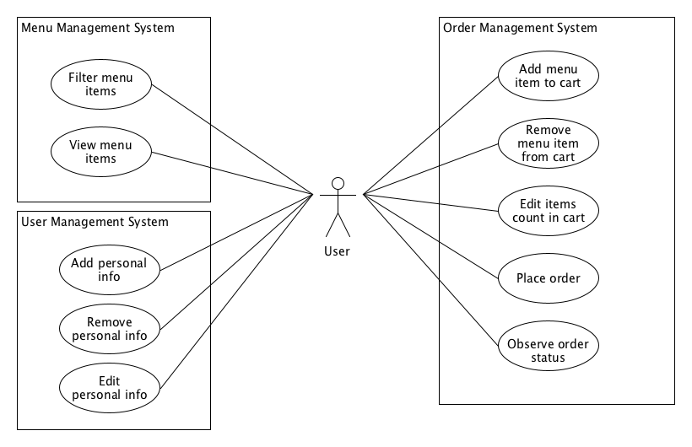

### Manager

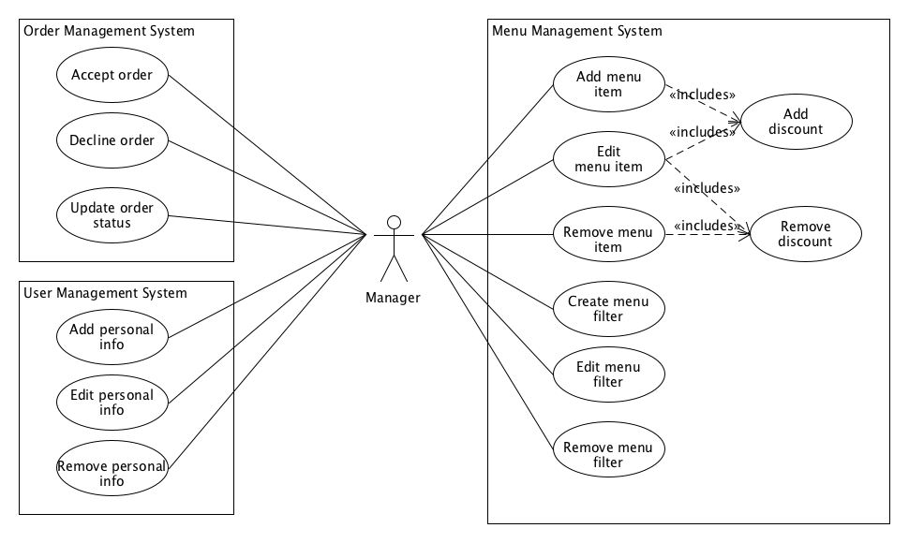

### Admin

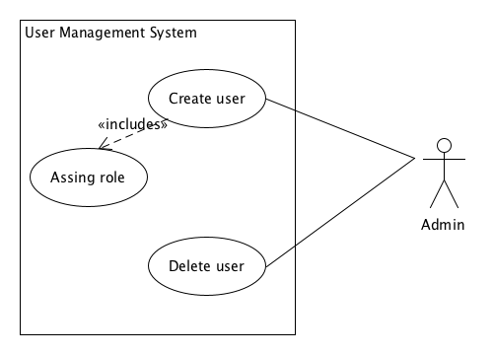

## Sequence

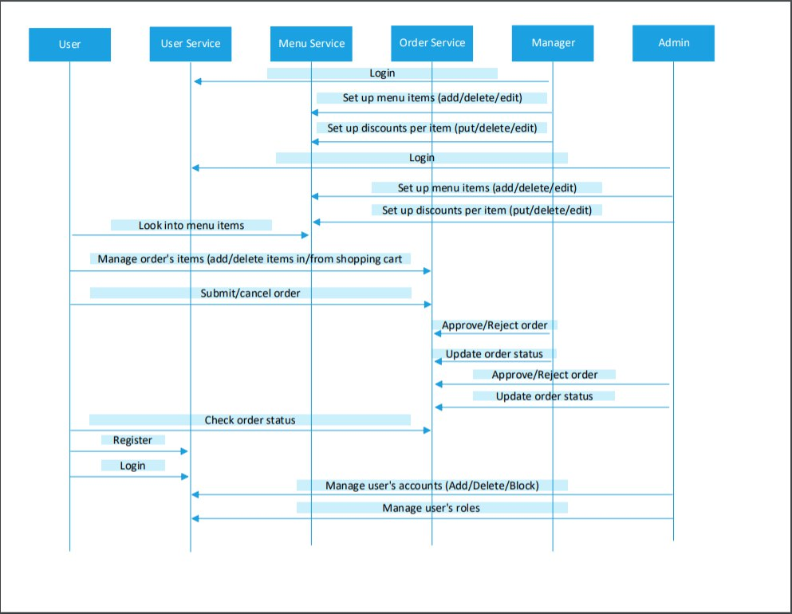

## Classes

